MEDIA PACK

Thank you for supporting the Capital Region Community Services (CRCS) annual Giving Tree Appeal. We would not be able to gift 100 hampers without the generous support of our local schools and businesses.
Any help you can provide is appreciated.
To make it easier for you to promote our appeal to parents and students in your school newsletter and social media, we’ve provided the following content and attached images to use. Please feel free to adapt this as required.

NEWSLETTER COPY

Title: Support Our Local Community This Holiday Season
Help us bring joy to children, families, and seniors in need this festive season by donating to the annual Capital Region Community Services (CRCS) Giving Tree Appeal. Your generosity will ensure everyone has a gift to open on Christmas Day and nourishing food to enjoy during this special time.
How You Can Help: CRCS welcome donations of new, unwrapped items such as:
- Children's toys
- Gift cards
- Board games
- Stocking fillers
- Movie vouchers
- Make-up and skin care
- Sports equipment
- Stationery gift packs
- Personal care items.
Drop off your donations at the Christmas tree located in the <school name> reception area, or at the Belconnen Community Centre, 23 Swanson Court, Belconnen.
For more information or to make an online donation, visit crcs.com.au/appeal or call us on (02) 6264 0200.
Together, we can make Christmas brighter for those who need it most.

SOCIAL MEDIA POST COPY
🎄 Support Our Local Community This Christmas! 🎁
Please help Capital Region Community Services (CRCS) to support our community.
Your donation of gifts and non-perishable food to the CRCS annual Giving Tree Appeal will help to make the festive season brighter for the children, families, and seniors in our community who need it the most. Your generosity will ensure that everyone has a present to open on Christmas day, and nourishing food to enjoy during this special time.
CRCS needs new, unwrapped donations of children’s toys, gift cards, board games, stocking fillers, movie vouchers, books and comics, make-up and skin care, sports equipment, and stationery gift packs.
📍 Drop off locations:
- <school name> reception area (under the Christmas tree)
- Belconnen Community Centre, 23 Swanson Court, Belconnen
For more info or to donate online, visit crcs.com.au/appeal or call (02) 6264 0200.
Let’s make the season brighter, together! ❤️ #GivingTree #CommunitySupport #ChristmasAppeal

Newsletter images
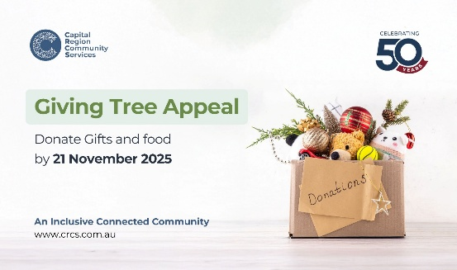

Social media posts
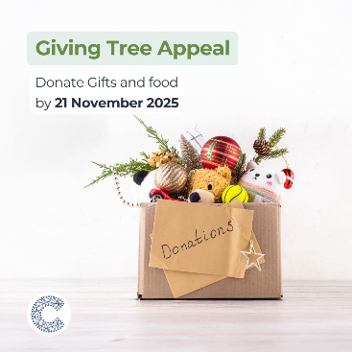
A poster and flyer are available to support your promotion of the Giving Tree Appeal. If you wish to print these you can download PDFs online at crcs.com.au/appeal.
For printed copies, please call us on (02) 6264 0200.

POSTER
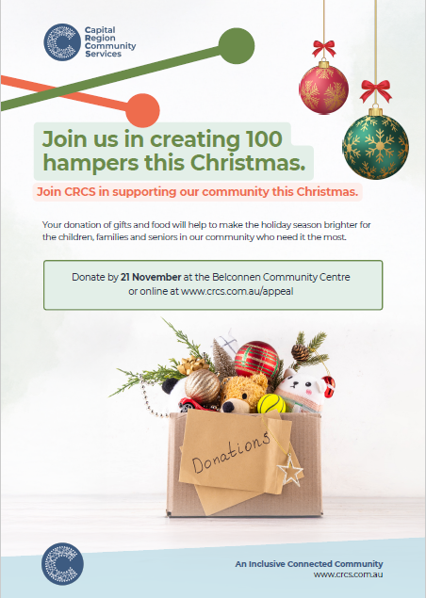

FLYER
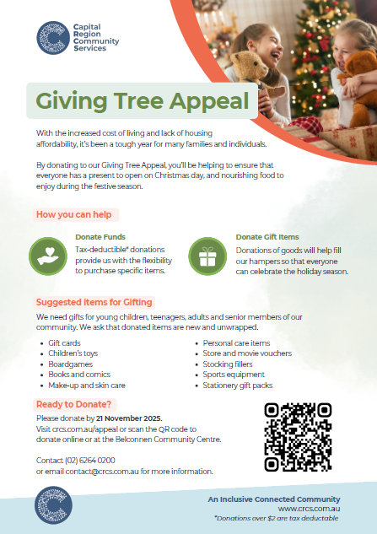

Need more information about this Media Pack?
Don't hesitate to contact the CRCS Marketing and Communications Team at marketing@crcs.com.au for assistance relating to this Media Pack and associated images.

